BANK LOAN REPORT QUERY DOCUMENT:
KPI’S:
- To see table in db:
SELECT * FROM bank_loan_data
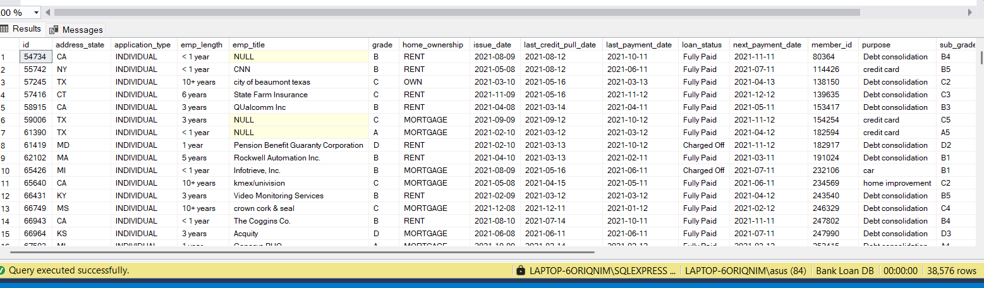
- Total loan applications:
SELECT COUNT(id) AS Total_Loan_Applications FROM bank_loan_data

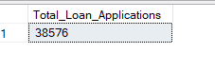
- MTD Total Loan applications:
SELECT COUNT(id) AS MTD_Total_Loan_Applications FROM bank_loan_data WHERE MONTH(issue_date) = 12 AND YEAR(issue_date) = 2021
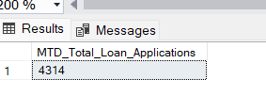
- PMTD Total Loan applications: (prev month)
SELECT COUNT(id) AS PMTD_Total_Loan_Applications FROM bank_loan_data WHERE MONTH(issue_date) = 11 AND YEAR(issue_date) = 2021
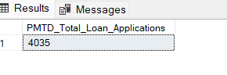
- Total Funded amount:
SELECT SUM(loan_amount) AS Total_Funded_Amount FROM bank_loan_data
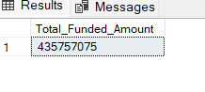
- MTD Total funded amount:
SELECT SUM(loan_amount) AS MTD_Total_Funded_Amount FROM bank_loan_data WHERE MONTH(issue_date) = 12 AND YEAR(issue_date) = 2021

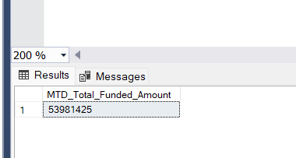

- PMTD Total funded amount:
SELECT SUM(loan_amount) AS PMTD_Total_Funded_Amount FROM bank_loan_data WHERE MONTH(issue_date) = 11 AND YEAR(issue_date) = 2021
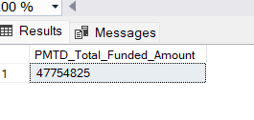
- Total amount received:
SELECT SUM(total_payment) AS Total_amount_recieved FROM bank_loan_data
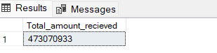
- MTD Total amount received:
SELECT SUM(total_payment) AS MTD_Total_amount_recieved FROM bank_loan_data WHERE MONTH(issue_date) = 12 AND YEAR(issue_date) = 2021
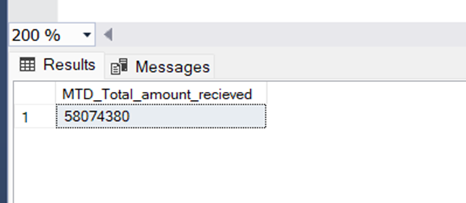

- PMTD Total amount received:
SELECT SUM(total_payment) AS PMTD_Total_amount_recieved FROM bank_loan_data WHERE MONTH(issue_date) = 12 AND YEAR(issue_date) = 2021
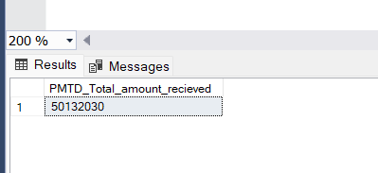

- Avg interest rate:
SELECT ROUND( AVG(int_rate),4) * 100 AS Avg_Interest_Rate FROM bank_loan_data

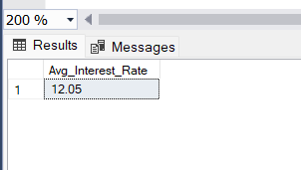
- MTD Avg interest rate:
SELECT ROUND( AVG(int_rate),4) * 100 AS MTD_Avg_Interest_Rate FROM bank_loan_data WHERE MONTH(issue_date) = 12 AND YEAR(issue_date) = 2021

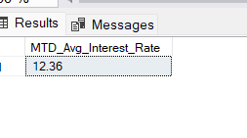
- PMTD Avg interest rate:
SELECT ROUND( AVG(int_rate),4) * 100 AS MTD_Avg_Interest_Rate FROM bank_loan_data WHERE MONTH(issue_date) = 12 AND YEAR(issue_date) = 2021

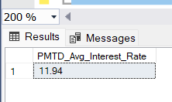
- Avg DTI:
SELECT ROUND( AVG(dti),4) * 100 AS Avg_DTI
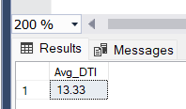

- MTD Avg DTI:
SELECT ROUND( AVG(dti),4) * 100 AS MTD_Avg_DTI FROM bank_loan_data WHERE MONTH(issue_date) = 12 AND YEAR(issue_date) = 2021
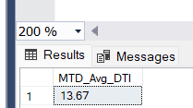
- PMTD Avg DTI:
SELECT ROUND( AVG(dti),4) * 100 AS PMTD_Avg_DTI FROM bank_loan_data WHERE MONTH(issue_date) = 11 AND YEAR(issue_date) = 2021
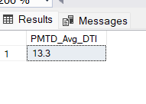
Good loan amount queries:
- Good loan % :
SELECT (COUNT (CASE WHEN loan_status = 'Fully Paid' OR loan_status = 'Current' THEN id END)*100)
/ COUNT (id) AS Good_loan_percenatge
FROM bank_loan_data
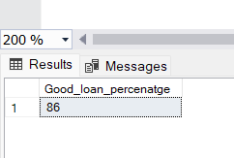

- Good loan total applications
SELECT COUNT (id)
AS good_loan_applications
FROM bank_loan_data
WHERE loan_status = 'Fully Paid'
OR loan_status = 'Current'

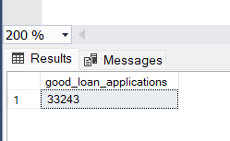

- Good loan funded amount:
SELECT SUM (loan_amount)
AS good_loan_funded_amount
FROM bank_loan_data
WHERE loan_status = 'Fully Paid'
OR loan_status = 'Current'

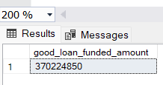
- Good loan received amount:

SELECT SUM (total_payment)
AS good_loan_amount_recieved
FROM bank_loan_data
WHERE loan_status = 'Fully Paid'
OR loan_status = 'Current'

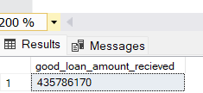

Bad loan amount queries:
- Bad loan % :
SELECT (COUNT (CASE WHEN loan_status = 'Charged Off' THEN id END)*100)
/ COUNT (id) AS Bad_loan_percenatge
FROM bank_loan_data
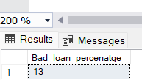

- Bad loan total applications
SELECT COUNT (id)
AS bad_loan_applications
FROM bank_loan_data
WHERE loan_status = 'Charged Off'

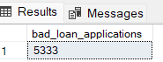

- Bad loan funded amount:
SELECT SUM (loan_amount)
AS bad_loan_funded_amount
FROM bank_loan_data
WHERE loan_status = 'Charged Off'
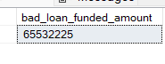
- Bad loan amount received:
SELECT SUM (total_payment)
AS bad_loan_funded_amount
FROM bank_loan_data
WHERE loan_status = 'Charged Off'
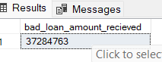

LOAN STATUS GRID QUERIES:
- Loan status :
SELECT
loan_status,
COUNT(id) AS Total_loan_applications,
SUM (total_payment) AS total_amount_recieved,
SUM(loan_amount) AS total_amount_funded,
AVG(int_rate * 100) AS interest_rate,
AVG(dti * 100) AS DTI
FROM
bank_loan_data
GROUP BY
loan_status
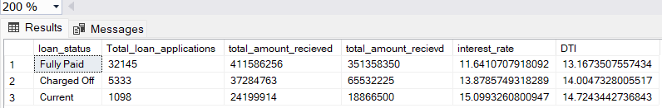

- MTD Loan status:

SELECT
loan_status,
SUM (total_payment) AS MTD_total_amount_recieved,
SUM(loan_amount) AS MTD_total_amount_funded
FROM
bank_loan_data
WHERE MONTH(issue_date) = 12
GROUP BY
loan_status

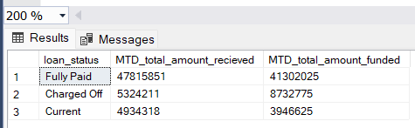
- Monthly trends( by issue date):

SELECT MONTH(issue_date) AS Month_number,
DATENAME(MONTH, issue_date) AS Month_name,
COUNT(id) AS Total_loan_applications,
SUM(loan_amount) AS total_funded_amount,
SUM(total_payment) AS total_recieved_amount
FROM bank_loan_data
GROUP BY MONTH(issue_date), DATENAME(MONTH, issue_date)
ORDER BY MONTH(issue_date)

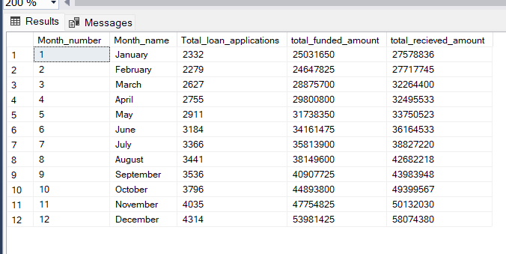

- Regional analysis( by address state):

SELECT
address_state,
COUNT(id) AS Total_loan_applications,
SUM(loan_amount) AS total_funded_amount,
SUM(total_payment) AS total_recieved_amount
FROM bank_loan_data
GROUP BY address_state
ORDER BY COUNT(id) DESC
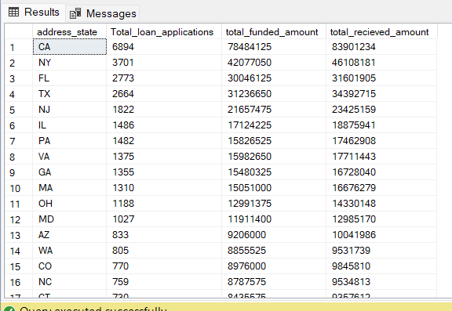
- Loan term (by term):

SELECT
term,
COUNT(id) AS Total_loan_applications,
SUM(loan_amount) AS total_funded_amount,
SUM(total_payment) AS total_recieved_amount
FROM bank_loan_data
GROUP BY term
ORDER BY term
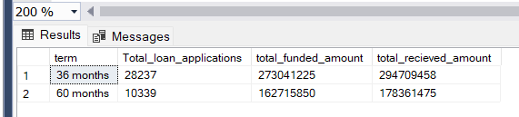

- Employee length(emp_length):

SELECT
emp_length,
COUNT(id) AS Total_loan_applications,
SUM(loan_amount) AS total_funded_amount,
SUM(total_payment) AS total_recieved_amount
FROM bank_loan_data
GROUP BY emp_length
ORDER BY emp_length

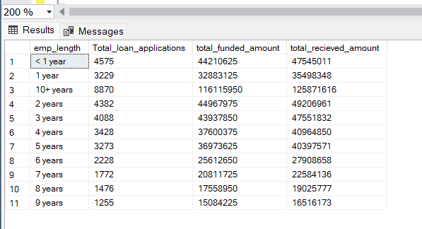
Or
SELECT
emp_length,
COUNT(id) AS Total_loan_applications,
SUM(loan_amount) AS total_funded_amount,
SUM(total_payment) AS total_recieved_amount
FROM bank_loan_data
GROUP BY emp_length
ORDER BY COUNT(id) DESC

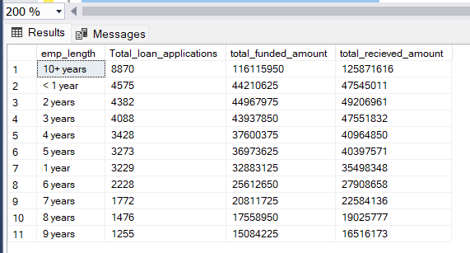

- Loan purpose ( by purpose):

SELECT
purpose,
COUNT(id) AS Total_loan_applications,
SUM(loan_amount) AS total_funded_amount,
SUM(total_payment) AS total_recieved_amount
FROM bank_loan_data
GROUP BY purpose
ORDER BY COUNT(id) DESC
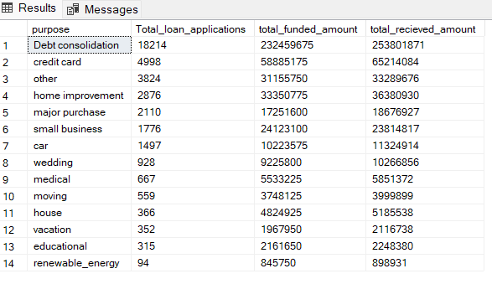

- Home ownership (home_ownership ):
SELECT
home_ownership,
COUNT(id) AS Total_loan_applications,
SUM(loan_amount) AS total_funded_amount,
SUM(total_payment) AS total_recieved_amount
FROM bank_loan_data
GROUP BY home_ownership
ORDER BY COUNT(id) DESC
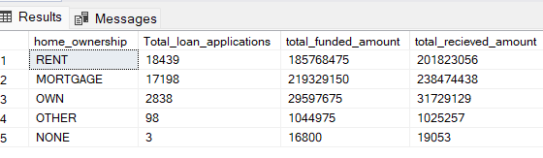

POWER BI REPORT:

SUMMARY:

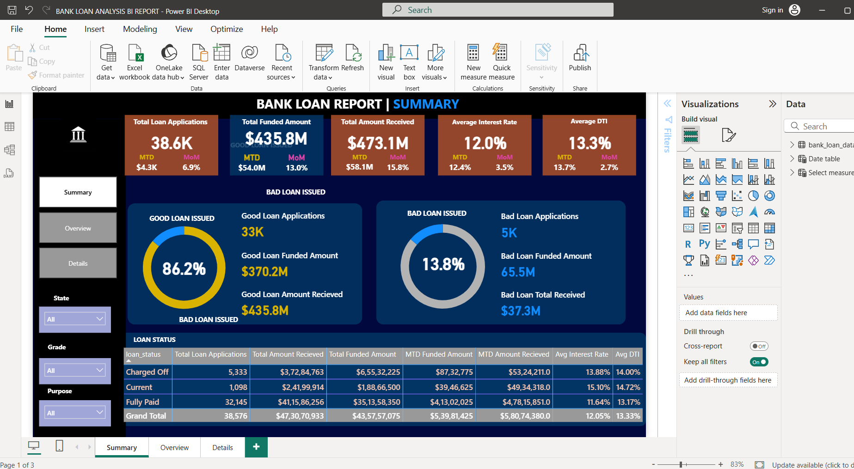
OVERVIEW: 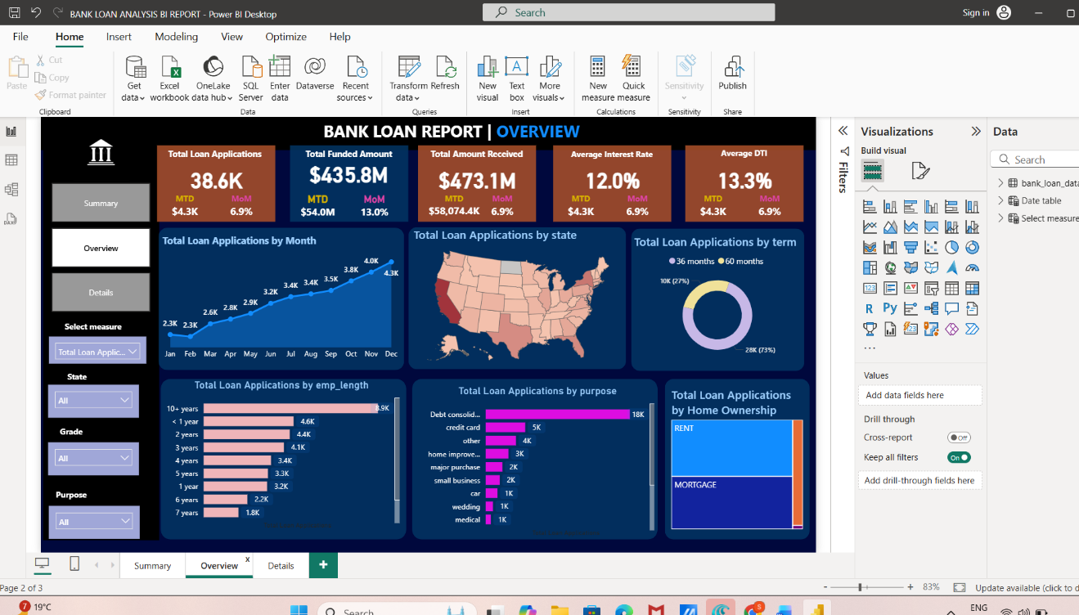

DETAILS:
